SIMATS ENGINEERING

ASSESSMENT TOOL 2: Industry Problem Solving Task

COURSE NAME: Cloud Computing and
Big Data Analytics

COURSE CODE: CSA15

COURSE OUTCOME COVERED
CO4: Analyze big data characteristics and challenges across domains including security and application aspects.
(BL4)
Assessment Tool Weightage: 20%
Dave&#39;s Taxonomy: Articulation (Level 4)
Question Count: 5

Total Marks: 40

Code of Conduct
I _Arthi Reddy(192565054) (Name / Reg No) certify that this submission is my original work and that I have adhered
to the guidelines specified for this assessment.
I understand that any violation of academic integrity rules will result in disciplinary action.
Signature of the student: ____________________
Assessment Tasks
Industry Problem Solving Task
1. An e-commerce company receives clickstream, transaction, and review data from millions of users daily.
Propose a big data analytics pipeline and explain how the 5Vs influence architecture design.
2. A healthcare organization collects structured patient records, semi-structured insurance claims, and unstructured
medical images. Design an approach to manage and secure this data ecosystem.
3. A telecom company wants to detect churn patterns using high-volume customer interaction data. Identify the
big data challenges and recommend suitable analytics and integration strategies.
4. A smart city project generates sensor streams from traffic, air quality, and surveillance systems. Explain how
distributed file systems and data integration tools can support large-scale analysis.
5. A financial analytics firm must comply with strict privacy requirements while processing high-velocity
transaction data. Design a secure big data solution and justify the controls chosen.
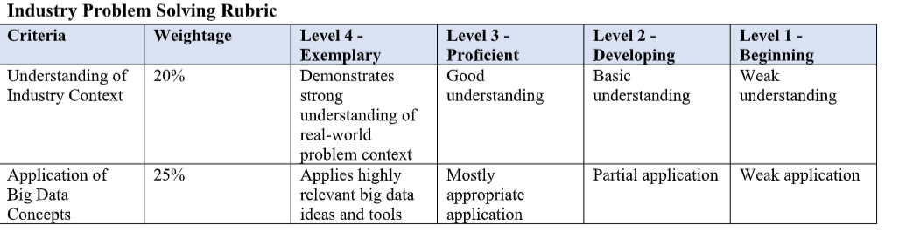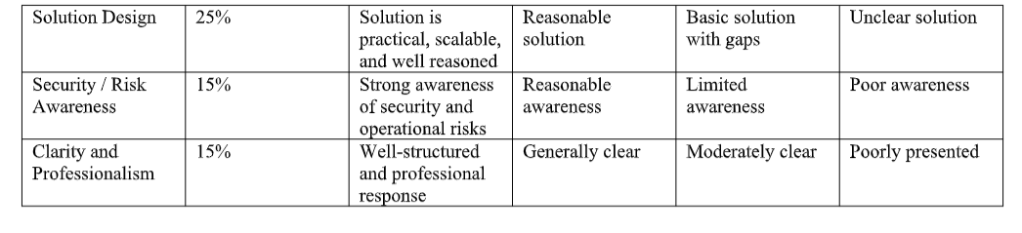

1. E-Commerce Big Data Analytics Pipeline
Problem
An e-commerce company receives clickstream, transaction, and review data from millions of users every day.
Proposed Big Data Pipeline
Data Sources → Data Ingestion → Distributed Storage → Data Processing → Analytics → Visualization
1. Data Sources
- Clickstream data from websites and mobile apps.
- Transaction and payment data.
- Customer reviews and feedback.
2. Data Ingestion
Tools such as Apache Kafka can collect high-speed streaming data.
3. Data Storage
A distributed storage system such as HDFS or cloud object storage can store massive datasets.
4. Data Processing
Apache Spark can process both batch and real-time data.
5. Analytics
Machine learning can be used for:
- Product recommendations.
- Customer behavior analysis.
- Fraud detection.
- Sales prediction.
6. Visualization
Dashboards can display sales, customer behavior, and product trends.
Influence of 5Vs on Architecture
5V | Influence on Architecture
Volume | Requires distributed and scalable storage
Velocity | Requires real-time data ingestion and processing
Variety | Requires systems capable of handling structured, semi-structured, and unstructured data
Veracity | Requires data cleaning and validation
Value | Requires analytics and visualization to convert data into business insights
Conclusion
A scalable, distributed, and real-time architecture is suitable for handling millions of e-commerce users and their continuously generated data.

2. Healthcare Data Management and Security
Problem
The healthcare organization handles:
- Structured patient records.
- Semi-structured insurance claims.
- Unstructured medical images.
Proposed Architecture
Data Sources → Data Integration → Secure Storage → Processing → Analytics
1. Data Collection
Collect patient records, insurance claims, and medical images from different systems.
2. Data Integration
Use integration/ETL tools to combine data from different sources into a common platform.
3. Data Storage
- Structured data → Relational database.
- Semi-structured data → NoSQL/data lake.
- Medical images → Distributed object/file storage.
4. Data Processing
Use distributed processing frameworks such as Spark for large-scale analysis.
5. Security
- Encryption: Protect data during storage and transmission.
- Authentication: Verify users before providing access.
- Authorization: Give users only the permissions they need.
- Audit Logs: Track who accessed or modified data.
- Data Masking: Hide sensitive patient information when required.
Conclusion
A secure data lake with strong access control, encryption, and auditing can manage different healthcare data types while protecting patient privacy.

3. Telecom Customer Churn Detection
Problem
A telecom company wants to identify customers who may stop using its services.
Big Data Challenges
1. High Data Volume
Millions of calls, messages, app interactions, and customer records are generated.
2. High Velocity
Customer interactions are generated continuously and may need real-time processing.
3. Data Variety
Data includes call records, customer profiles, complaints, messages, and app activity.
4. Data Quality
Missing or incorrect customer information can affect prediction accuracy.
Analytics Strategy
Use machine learning to identify churn patterns.
Steps
- Collect customer interaction data.
- Clean and integrate the data.
- Extract features such as call frequency, complaints, and usage.
- Train a churn prediction model.
- Identify high-risk customers.
- Provide special offers or support to retain them.
Integration Strategy
- Use Kafka for real-time data ingestion.
- Use Spark for large-scale processing.
- Use ETL tools to integrate customer data from multiple systems.
- Store historical data in a distributed data lake.
Conclusion
Real-time ingestion combined with distributed processing and machine learning can help telecom companies predict and reduce customer churn.

4. Smart City Big Data Architecture
Problem
Smart city systems generate continuous sensor data from:
- Traffic systems.
- Air-quality sensors.
- Surveillance systems.
Role of Distributed File Systems
A distributed file system such as HDFS can:
- Store huge amounts of sensor data.
- Divide data across multiple nodes.
- Provide fault tolerance.
- Support parallel processing.
- Scale by adding additional nodes.
Role of Data Integration Tools
Integration tools can:
- Collect data from different sensors.
- Convert data into a common format.
- Clean and validate sensor data.
- Combine traffic, air-quality, and surveillance data.
- Transfer data to storage and analytics platforms.
Processing
Kafka → HDFS/Data Lake → Spark → Analytics → Dashboard
Applications
- Traffic congestion prediction.
- Air pollution monitoring.
- Accident detection.
- Smart parking.
- Public safety monitoring.
Conclusion
Distributed storage provides scalability and reliability, while integration tools combine data from multiple sources for large-scale smart-city analytics.

5. Secure Big Data Solution for Financial Analytics
Problem
A financial analytics firm processes high-velocity transaction data and must follow strict privacy requirements.
Proposed Architecture
Transaction Sources → Secure Ingestion → Encrypted Storage → Secure Processing → Analytics → Monitoring
1. Secure Data Ingestion
Use secure streaming systems to collect transaction data while protecting it during transmission.
2. Encryption
- Encrypt data at rest.
- Encrypt data in transit.
- Protect encryption keys using secure key management.
3. Access Control
Use role-based access control (RBAC) so employees can access only the data required for their jobs.
4. Authentication
Use strong authentication and preferably multi-factor authentication (MFA) for sensitive systems.
5. Data Masking
Mask sensitive information such as account numbers when full information is not required.
6. Audit and Monitoring
Maintain logs of:
- User access.
- Data modifications.
- Failed login attempts.
- Suspicious activities.
7. Real-Time Fraud Detection
Use streaming analytics to identify unusual transactions quickly.
Why These Controls Are Important
Control | Purpose
Encryption | Protects sensitive financial data
RBAC | Prevents unauthorized access
MFA | Provides stronger authentication
Data Masking | Protects confidential information
Audit Logs | Supports monitoring and accountability
Real-Time Analytics | Detects fraud quickly
Conclusion
A secure Big Data architecture using encryption, access control, authentication, masking, auditing, and real-time analytics can process high-speed financial transactions while protecting privacy and reducing security risks.

